1. Problem1 – output

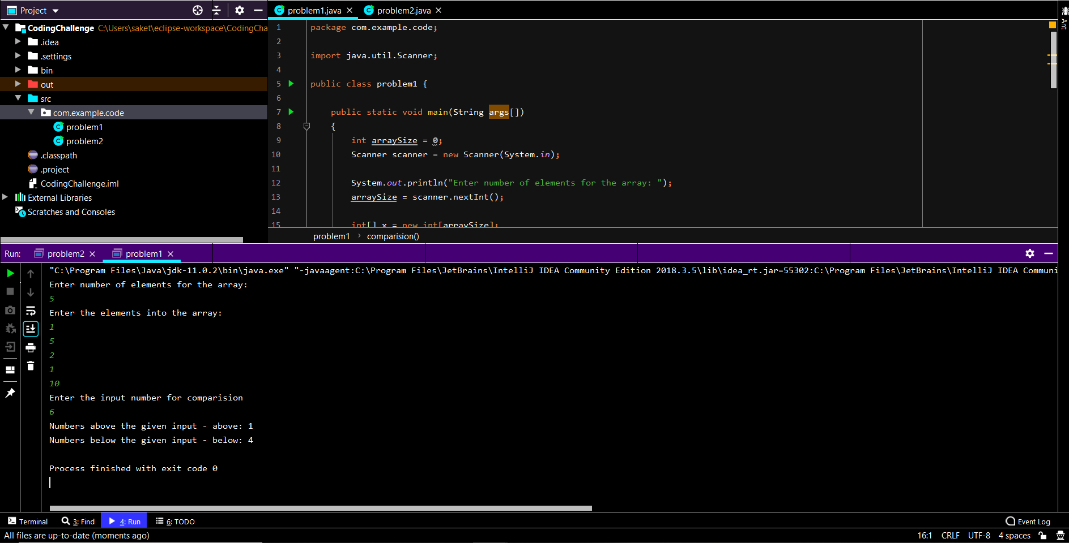

1. Problem2 – output

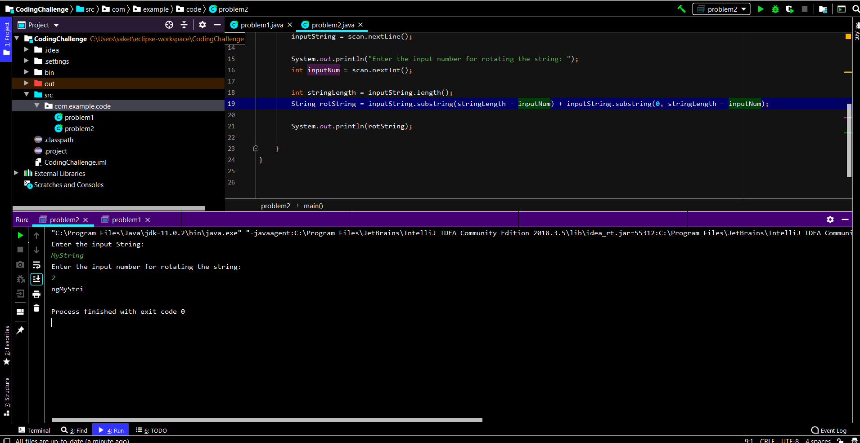

1. I’ve been learning and using Java as a part of my work and I like working on it. I know its not easy to learn Java because of the it’s vast knowledge it holds. The more I learn Java every day, more I understand how much is left for to learn about it. But the complexity of Java is felt when I’m learning it. I think Java should have libraries (like Python libraries) to simplify its understanding. For instance, Swapping in Python can be done with simple swap command whereas Java swap is a method with a swap function when I was learning. (I know Java Collections has a swap method which was included since Java 8 but this is just an example I wanted to quote). I think it should be more like natural language rather than it’s current syntaxes.